Indefinite Quantifiers

🌫️ What Are Indefinite Quantifiers?
# Source: AI Source: Provided by: [Data Path: Persons Table -> ID Column: 1, Name_En Column: Motasem Essam] -> From: [ChatGPT] on [7/28/2025]
Indefinite quantifiers are words that express an unknown or non-specific quantity of something.
They don’t tell us the exact number or amount — just “some,” “many,” “few,” “all,” “none,” etc.
They are used with both countable and uncountable nouns.

✅ Common Indefinite Quantifiers
# Source: AI Source: Provided by: [Data Path: Persons Table -> ID Column: 1, Name_En Column: Motasem Essam] -> From: [ChatGPT] on [7/28/2025]
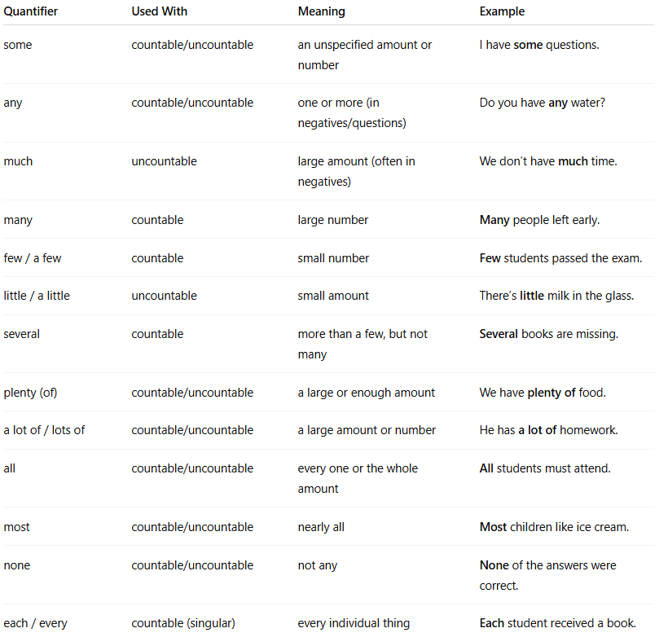
Quantifier | Used With | Meaning | Example
some | countable/uncountable | an unspecified amount or number | I have some questions.
any | countable/uncountable | one or more (in negatives/questions) | Do you have any water?
much | uncountable | large amount (often in negatives) | We don’t have much time.
many | countable | large number | Many people left early.
few / a few | countable | small number | Few students passed the exam.
little / a little | uncountable | small amount | There’s little milk in the glass.
several | countable | more than a few, but not many | Several books are missing.
plenty (of) | countable/uncountable | a large or enough amount | We have plenty of food.
a lot of / lots of | countable/uncountable | a large amount or number | He has a lot of homework.
all | countable/uncountable | every one or the whole amount | All students must attend.
most | countable/uncountable | nearly all | Most children like ice cream.
none | countable/uncountable | not any | None of the answers were correct.
each / every | countable (singular) | every individual thing | Each student received a book.

🧠 Notes:
# Source: AI Source: Provided by: [Data Path: Persons Table -> ID Column: 1, Name_En Column: Motasem Essam] -> From: [ChatGPT] on [7/28/2025]
- “Some” is usually used in positive statements.
- “Any” is usually used in negative sentences or questions.
- “A few” and “a little” suggest a small, but positive amount.
- “Few” and “little” suggest a small and possibly insufficient amount.

